Задача 5. Найти производную.
5.1.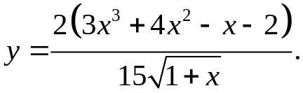

(9x²+8x-1)(x+1)^{1/2} – (3x³+4x²-x-2)
y'=2/15* ___________________2(1+x)^{1/2} =
1+x
= 2/15* (2x+2)(9x²+8x-1)-3x³-4x²+x+2 =
2(x+1)^{3/2}
=2/15* 18x³+16x²-2x+18x²+16x-2-3x³-4x²+x+2 =
2(x+1)^{3/2}
= 2/15* 15x³+30x²+15x =
2(x+1)^{3/2}
= x(x+1)² = x(x+1)^{1/2}
(x+1)^{3/2}

5.2. 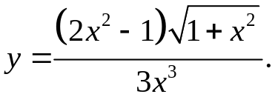
3x³*4x(x²+1)^{1/2}+x(2x²-1) -9x²(2x²-1)(x²+1)^{1/2}
y'= (x²+1)^{1/2} =
9x⁶
= 12x⁴(x²+1)+3x⁴(2x²-1)-9x²(2x²-1)(1+x²) =
9x⁶(x²+1)^{1/2}
= 12x⁴+12x⁶+6x⁶-3x⁴-18x⁴-18x⁶+9x²+9x⁴ =
9x⁶(x²+1)^{1/2}
= 9x² = 1 .
9x⁶(x²+1)^{1/2} x⁴(x²+1)^{1/2}
5.3. 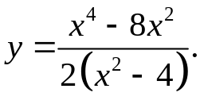
y'= (4x³-16x)(x²-4)-(x⁴-8x²)2x = 4x⁵-16x³-16x³+64x-2x⁵+16x³ =
2(x²-4)² 2(x²-4)²
=2x⁵-16x³+64x =x(x²-4)²+16x = x+ 16x² .
2(x²-4)² (x²-4)² (x²-4)²
5.4. 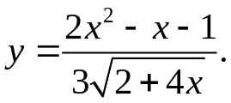
(4x-1)√(2+4x) – 2(2x²-x-1)
y'= √(2+4x) = (4x-1)(2+4x)-4x²+x+1 =
3(2+4x) 3(2+4x)√(2+4x)
= 12x²+5x-1 .
3(2+4x)√(2+4x)
5. 5. 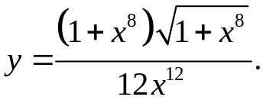
8x¹⁹√(1+x⁸)+ 4x¹⁹(1+x⁸) – 12x¹¹(1+x⁸)^{3/2}
y'= √(1+x⁸) =
12x²⁴
= 12x¹⁹(1+x⁸)-12x¹¹(1+x⁸)² =
12x²⁴√(1+x⁸)
= x11(x16-2x8+1) = (x8-1)2 .
x²⁴√(1+x⁸) x¹³√(1+x⁸)
5.6. 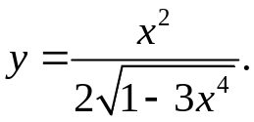

2x√(1-3x⁴) + 6x⁵
y'= √(1-3x⁴) = 2x(1-3x⁴)+6x⁵ = x .
2(1-3x⁴) 2(1-3x⁴)√(1-3x⁴) √(1-3x⁴)³

5.7. 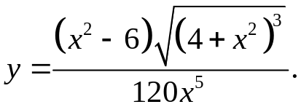

y= (2x(4+x²)√(4+x²)+3/2√(4+x²)*2x)x⁵-(x²-6)(4+x²)√(4+x²)*5x⁴ =
120x¹⁰
= √(4+x²)(8x⁶+2x⁸+3x⁶-20x⁶-5x⁸+30x⁶+120x⁴) =
120x¹⁰
= √(4+x²)(7x²-x⁴+40)
40x⁶

5.8. 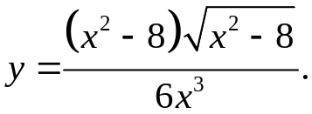

y= 3/2√(x²-8)*2x⁴-(x²-8)√(x²-8)*18x² =
6x⁶
√(x²-8)(x⁴-6x⁴+48x²) = √(x²-8)(48-5x²)
3x⁶ 3x⁴
5.9. 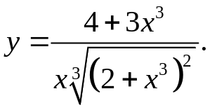

9x³(2+x³)^{2/3}-(4+3x³)((2+x³)^{2/3}+2/3* 3x³ )
y'= (2+x³)^{1/3} =
x²(2+x³)^{4/3}
= 9x³(2+x³)-(4+3x³)(2+3x³) = 8 .
x²(2+x³)^{5/3} x²(2+x³)^{5/3}

5.10. 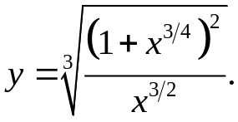
y'= √(x)*(2(1+x^{3/4})*3/4x^{5/4}-(1+x^{3/4})²*3/2*√(x)) =
3(1+x^{3/4})^{2/3}*x^{6/4}
= √(x)(x^{3/2}-1)
2x(1+x^{3/2})^{2/3}
5.11. 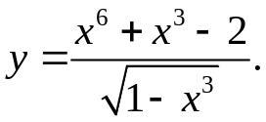

(6x⁵+3x²)√(1-x³) + 3x²(x⁶+x³-2)
y' = 2√(1-x³) =
1-x³
=(2-2x³)(6x⁵+3x²)+3x⁸+3x⁵-6x² = (9x⁵-9x⁸) = 9x⁵ .
2(1-x³)^{3/2} 2(1-x³)^{3/2} 2√(1-x³)

5.12. 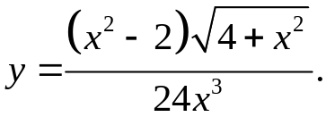
2x⁴√(4+x²)+ x⁴(x²-2) -3x²(x²-2)√(4+x²)
y'= √(4+x²) =
24x⁶
= 2x⁴(4+x²)+x⁴(x²-2)-3x²(x²-2)(4+x²) = 1
24x⁶ x⁴

5.13. 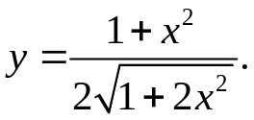
2x√(1+2x²)- 2x(1+x²)
y'= √(1+2x²) = x(1+2x²)-x(1+x²) = x^{3 .}
2(1+2x²) (1+2x²)^{3/2} (1+2x²)^{3/2}
5.14. 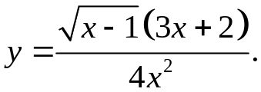
y'= ((3x+2)/(2√(x-1))+3√(x-1))x²-2x√(3x+2) =
4x⁴

= x²(3x+2)+6x²(x-1)-4x(x-1)(3x+2) = 9x³-12x²+8x = 9x²-12x+8
4x²√(x-1) 4x²√(x-1) 4x√(x-1)
5.15. 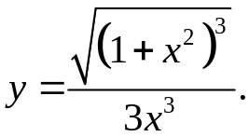
y'= 3/2*√(1+x²)*2x⁴-3x²(1+x²)^{3/2} = √(1+x²)*(x⁴-x²-x⁴) = -√(1+x²)
3x⁶ x⁶ x⁴
5.16. 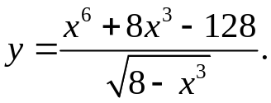
(6x⁵+24x²)√(8-x³)+3x²(x⁶+8x³-128)
y'= 2√(8-x³) =
8-x³
= (16-2x³)(6x⁵+24x²)+3x²(x⁶+8x³-128) = 72x⁵-9x⁸ = 9x⁵
2(8-x³)^{3/2} 2(8-x³)^{3/2} 2√(8-x³)
5.17. 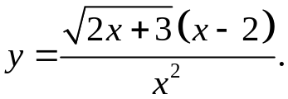
x²(x-2)+x²√(2x+3)-(2x²-4x)√(2x+3)
y'= √(2x+3) =
x⁴
= x²(x-2+2x+3)-(2x²-4x)(2x+3) = 3x²-x³+12x = 3x-x²+12
x⁴√(2x+3) x⁴√(2x+3) x³√(2x+3)
5.18. 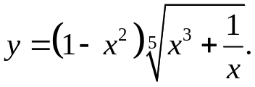

y'=-2x⁵√(x³+1/x)+(1-x²)*1/5*(x³+1/x)^{4/5}*(3x²-1/x²)=1/5*(x³+1/x)^{4/5}(3x²-1/x²-3x⁴+1)-2x(x³+1/x)^{1/5}
5.19. 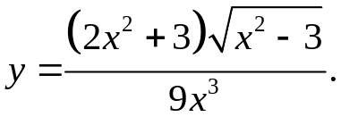
4x⁴√(x²-3)+x⁴(2x²+3) - 3x²(2x²+3)√(x²-3)
y' = √(x²-3) =
9x⁶
= 4x⁴(x²-3)+x⁴(2x²+3)-3x²(2x²+3)(x²-3) = 27x² = 3 .
9x⁶√(x²-3) 9x⁶√(x²-3) x⁴√(x²-3)
5.20. 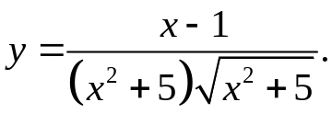
y'= (x²+5)^{3/2}-3/2*(x-1)√(x²+5)*2x = √(x²+5)(5+3x-2x²)
(x²+5)³ (x²+5)³
5.21. 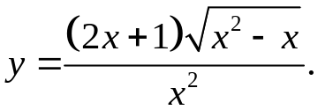
2x²√(x²-x)+(2x-1)(2x+1)x²-2x(2x+1)√(x²-x)
y'= √(x²-x) =
x⁴
= x²(2x²-2x+4x²-1)-(4x²+2x)(x²-x) = 2x²+1
x⁴ x²

5.22. 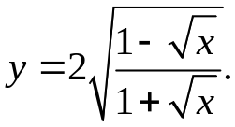
_ 1+√x _ 1-√x
y' = √((1+√x)/(1-√x))* 2√x 2√x =
(1+√x)²
= -2√((1+√x)/(1-√x)) = -1 .
2√x(1+√x)² √(x(1-x))(1+√x)
5.23. 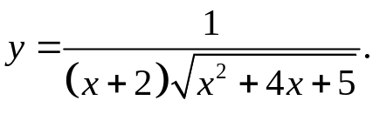
√(x²+4x+5) - x(x+2)
y' = √(x²+4x+5) = - 2x²-6x-5 .
(x+2)2(x²+4x+5) (x+2)2(x²+4x+5)^{3/2}
5.24. 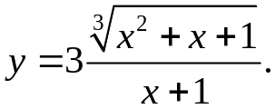
2x+1 -3(x²+x+1)^{1/3}
y' = (x²+x+1)^{2/3} = -3x²-x-2 .
(x+1)² (x+1)²(x²+x+1)^{2/3}
5.25. 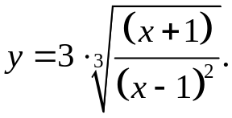
y'= 3√((x-1)⁴/(x+1)²)*(x-1)²-2(x-1)(x+1) = -3√((x-1)⁴/(x+1)²)*x²+2x-3 =
(x-1)⁴ (x-1)⁴
= 3-x²-2x
(x2-1)^{2/3}(x-1)²
5.26. 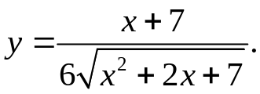
√(x²+2x+7)-(x+1)(x-1)
y' = √(x²+2x+7) = x²+2x+7-x²-8x-7 = -x .
6(x²+2x+7) 6(x²+2x+7)^{3/2} (x²+2x+7)^{3/2}

5.27. 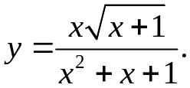
y' = (x²+x+1)(√(x+1)+x/(2√(x+1)))-(2x²+x)√(x+1) =
(x²+x+1)²
= (3x+2)(x²+x+1)-(4x²+2x)(x+1) = -x³-x²+3x+2
2(x²+x+1)√(x+1) 2(x²+x+1)√(x+1)
5.28. 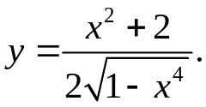
y' = 2x√(1-x⁴)+2x(x²+2)/√(1-x⁴) = 3x-x⁵+x³
2-2x⁴ (1-x⁴)^{3/2}
5.29. 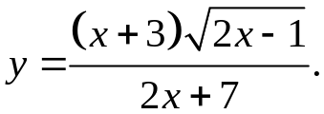
y' = (√(2x-1)+(x+3)/√(2x-1))(2x+7)-(2x+6)√(2x-1) =
(2x+7)²
= (3x+2)(2x+7)-(2x+6)(2x-1) = 2x²+15x+20
(2x+7)²√(2x-1) (2x+7)²√(2x-1)
5.30. 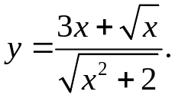
y' = (3+1/(2√x))√(x2+2)-(3x+√x)x/√(x²+2) =
x²+2
= (6√x+1)(x²+2)-2x√x(3x+√x) = 12√x+2-x²
2√x(x²+2)^{3/2} 2√x(x²+2)^{3/2}
5.31. 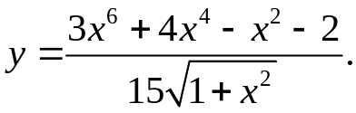
y' = (18x⁵+16x³-2x)√(1+x²)-x(3x⁶+4x⁴-x²-3)/√(1+x²) = 16x⁷+14x⁵+16x⁴+15x³
15+15x² 15(1+x²)^{3/2}

